KS1 How do some Muslims show Allah is compassionate and merciful?
What should I know?
Knowledge gems | THEOLOGY  Beliefs | SOCIOLOGY  Practice | PHILOSOPHY  Thinking
 | 1. I know the story of Muhammad and the Crying Camel. | 4. I know what many Muslims do during Ramadan. | I know how to contribute ideas to the question – who is it right to follow?
 | 2.I know a story about Muhammad and an animal.  3. I know Muslims believe the prophet Muhammed was a messenger from God. | 5. I know how many Muslims celebrate Eid-ul-Fitr.
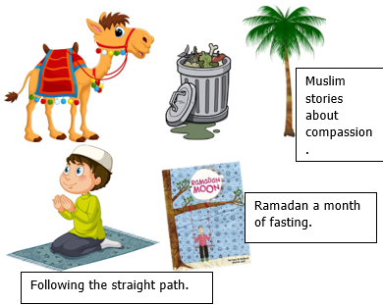
That Muslims believe in Allah – the one true God. Muslims believe:
- That Allah is a compassionate God.
- That if Allah is compassionate, Muslims should be too.
- Allah wants Muslims to look after all living creatures.
- That Muhammad is an example for all Muslims to follow.
- That being hungry helps them feel compassion for those in need.

What words should we understand and be able to use?
Qur’an | A Muslim’s special holy book. Always treated with respect and never put on the floor. | Arabic | The language of the Qur’an and the language spoken in the Middle East.
Muhammad | Allah’s last prophet (his messenger). He is very special to all Muslims. | Compassionate | Feeling and showing concern for others.
Allah | The Arabic word for God. | Islam/Muslims | Muslims are followers of the religion Islam.
Ramadan | Ramadan is a holy month in the Islamic calendar when Muslims fast, pray, and worship | Fasting | A time when no food or drink is eaten
Bismillah | an Arabic phrase that means ‘in the name of God, the merciful and compassionate’ | Eid-ul-Fitr | The celebration at the end of Ramadan

