UKS2 Why is the gospel such good news for Christians?
What should I know?
Cycle B  Autumn 1 | Theology - beliefs | Sociology - practice | Philosophy - thinking
 | 2. I know that the Bible writes of the birth of Jesus as ‘good news’ or ‘glad tidings.’ | 4. I know ways the gospel is shown to be of great value in a church. | I know how to contribute ideas to the question – where do people look for answers about life and living?
 | 3. I know the Gospels are the good news of Jesus. | 5. I know how Jesus’ teaching affects Christians in their daily lives. | 1. I know how to wonder about what good news is to me and different people.

The gospel writers are Matthew, Mark, Luke and John.
Remember, to Christians, Jesus is good news.
Christians believe:
- Jesus is the saviour of the world. This is good news.
- The Gospels are the books of Matthew, Mark, Luke and John. They are found in the Bible and tell the stories of Jesus.
- Christians live by the Bible and by the things Jesus said.
The teachings of Jesus have authority in their life.




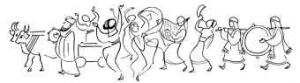
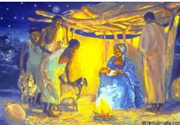

What words should we understand and be able to use?
Lectern | A tall stand with a sloping top to hold a book or notes, from which someone, typically a preacher or lecturer, can read while standing up. | Herod | A Roman Jewish King.
Authority | The power to give orders or make decisions : the power or right to direct or control someone or something. | Gospel | The teachings of Jesus. Also the record of his life and teaching in the first four books of the New Testament.
Account | A report or description of an event or experience. | Pulpit | A raised enclosed platform in a church or chapel from which the preacher delivers a sermon.

