LKS2 How do Christians show that reconciliation with God and others is important?
What should I know?
Knowledge gems | THEOLOGY  Beliefs | SOCIOLOGY  Practice | PHILOSOPHY  Thinking
 | 2. I know what a Christian might learn from the story of the Prodigal Son. | 4. I know why Christians think it is important to say sorry to God. | I know how to contribute ideas to the question – do beliefs make any different to someone’s life?
 | 3.I know how to use a bible to find the story of the Prodigal Son. | 5. I know how Desmond Tutu became a peacemaker. | 1. I know what it means to be a peacemaker.

Reconciliation is about fixing what is broken.
Christians believe:
- The world needs reconciliation.
- The Bible and stories Jesus told teach about reconciliation.
- God offers forgiveness to all who repent and admit wrongdoing.
- Asking God for forgiveness is called confession.
- That God wants us all to be peacemakers.

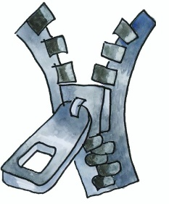
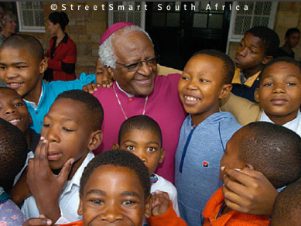

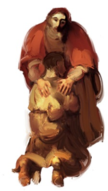

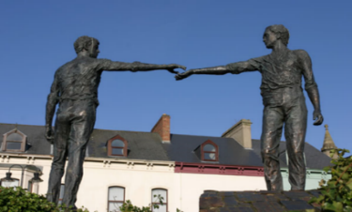

What words should we understand and be able to use?
Parable | Stories Jesus told to help his followers learn more about God; they are like mystery stories with lots of special meanings in them. | Reconciliation | Reconciliation is the technical word for mending friendships. It can be the mending of a broken friendship with God or with others.
Desmond Tutu | A South African Anglican bishop known for his work as an anti-apartheid and human rights activist | Lectern | a tall stand with a sloping top to hold a book or notes, from which someone, typically a preacher or lecturer, can read while standing up.
Sermon | a talk, especially one given during a church service and based on a passage from the Bible. | Sculpture | the art of making three-dimensional forms, especially by carving stone or wood or by casting metal or plaster.
Confession | Saying sorry for a sin (wrong thought or action) | Absolution | formal release from guilt, obligation, or punishment.
Prayer | Talking to God to give thanks or ask for help or guidance | Archbishop | a bishop of the highest rank who is in charge of churches and other bishops in a particular large area.

