LKS2 How does a Muslim show their submission and obedience to Allah?
What should I know?
Knowledge gems | THEOLOGY  Beliefs | SOCIOLOGY  Practice | PHILOSOPHY  Thinking
 | 3. I know why Bilal chosen as the first muezzin. | 2. I know the adhan is the Muslim call to prayer. I know what it tells Muslims to do. | I know how to contribute ideas to the question – do beliefs make any different to someone’s life?
 |  | 4. I know how a Muslim gets ready for prayer.  5. I know some of the ways Muslims greet one another. | 1. I know what it means to obey.
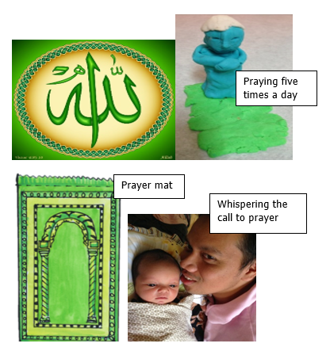
That submission is about recognising that Allah is to be obeyed at all times.
That Muslims believe:
- That Allah is the one true God; the most important being in the universe.
- That Allah should be obeyed in every way and Muslims trust him to tell them the right thing to do.
- That praying five times a day helps them to remember to submit to Allah in all they do.

What words should we understand and be able to use?
Submission | For a Muslim this means obeying Allah as creator of all. | Adhan | The Adhan is the Muslim call to prayer performed in Arabic. It announces the beginning of a set period of prayer.
Bismillah | This means ‘in the name of Allah.’ The first words in their holy book. Muslims says this before starting anything. | Muezzin  (mu’adhin) | One who calls the adhan, five times a day, by a muezzin from the top of a minaret (tower on the mosque).
Salat | The ritual prayer of Muslims, performed five times daily in a set form. | Muslim | A follower of Islam. One who submits to Allah.


