UKS2 What does the Qur’an reveal about Allah and his guidance?
What should I know?
Knowledge gems | THEOLOGY  Beliefs | SOCIOLOGY  Practice | PHILOSOPHY  Thinking
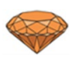 | 3. I know how the Qur’an was revealed in cave Hira. | 2. I know how Muslims show respect to the Qur’an. | I know how to contribute ideas to the question – where do people look for answers about life and living?
 |  | 4. I know how the Qur’an is memorized at a Madrassah.  5. I know how Allah’s guidance affects how a Muslim lives their life. | 1. I know what it means to reveal something,
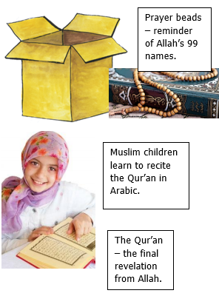
Revelation is how Allah imparts whatever he wishes to those he chooses.
Muslims believe:
- The greatest revelation has come from Allah to the Prophet Muhammad and is recorded in the Qur’an.
- The Qur’an reveals what God is like, provides guidance for living and the key to preparation for the life to come.
- The words of the Qur’an are the actual words of Allah received over a period of time by the Prophet Muhammad through the Angel Jibreel (Gabriel).

What words should we understand and be able to use?
Revelation | How Allah makes himself known to Earth. | Cave Hira | Where Muhammad received the Qur’an.
Madrassah | A Muslim school (often part of the Mosque). Children learn to recite the Qur’an here often two hours after school and on a Saturday. | Hafiz | Someone who has memorised the Qur’an off by heart.
Muslim | A follower of Islam. One who submits to Allah. | Gabriel | The name of the angel who spoke to Muhammad.
Allah | The Arabic word for God | Subha beads | Used by many Muslims to help them pray.
Surah | A chapter of the Qur’an | Mosque | The Muslim place of worship

