KS1 Why do Christians pray to God and worship him?
What should I know?
Knowledge gems | THEOLOGY  Beliefs | SOCIOLOGY  Practice | PHILOSOPHY  Thinking
 | 3. I know Jesus taught his followers to pray. This is the Lord’s Prayer. | 1. I know many Christians say a prayer at mealtimes.  2. I know Christians say different kinds of prayers. | I know how to contribute ideas to the question – should everyone learn to pray?
4. I know Christians go to church to celebrate God.
5. I know what a prayer of intercession is.

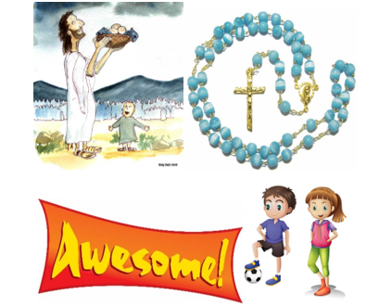
Christians believe:
- God is with them, listening when they want to talk to him.
- God is like the best kind of parent. They can talk to him about everything.
- Jesus taught his disciples to pray by teaching them The Lord’s prayer.
Christians pray in different ways.
Christians go to church to tell God how great he is.

What words should we understand and be able to use?
Pray | Talking with and listening to God. | Blessing | A special type of prayer.
Worship | Showing great respect and love for God | Lord’s Prayer | A special prayer Jesus taught his disciples.
Rosary beads | An aid to help with prayer | Intercession | Praying to God on behalf of someone else


