KS1 Why do Jewish families say so many prayers and blessings?
What should I know?
Knowledge gems | THEOLOGY  Beliefs | SOCIOLOGY  Practice | PHILOSOPHY  Thinking
 | 3. I know Jewish people have a day of rest each week called Shabbat | 1. I know that Jewish families build a Sukkah  2. I know how Jewish children say thank you to God. | I know how to contribute ideas to the question – should everyone learn to pray?
4. I know how a Jewish family get ready for Shabbat.
5. I know how the Jewish community pray at the synagogue.

Jewish people:
- Say prayers and blessings to God because it reminds them how great God is.
- Say thank you to God for all he provides.
- Have a day of rest each week called Shabbat.
- Pray at both home and the synagogue.
- Sometimes wear special clothes.

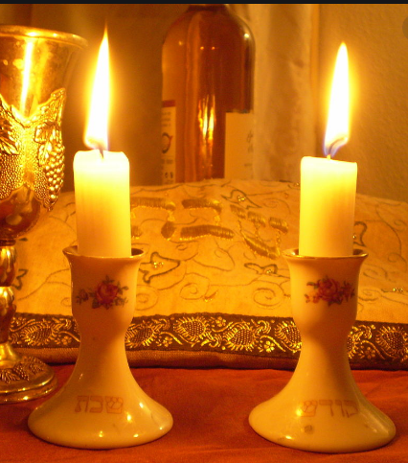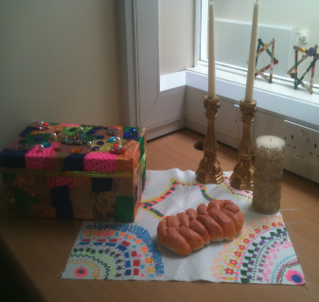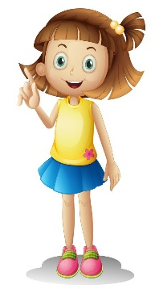
‘Blessed are you, Lord our GOD, King of the Universe’



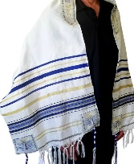
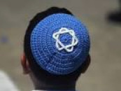
What words should we understand and be able to use?
Sukkah | A special hut built during the festival Sukkot. | Synagogue | Known as the ‘House of Prayer,’ a Jewish community house.
Shabbat | The Jewish day of rest. | Tallit | Jewish prayer shawl.
Kippah | A head covering for Jews. | Havdalah ceremony | marks the end of Shabbat.

