UKS2 Should believing in the resurrection change how Christians view life and death?
What should I know?
Knowledge gems | THEOLOGY | SOCIOLOGY | PHILOSOPHY
 | I know the sequence of Bible stories from Palm Sunday to Easter Sunday. | I know the word Hallelujah is an important word in Easter worship. It is Hebrew for ‘Praise the LORD.’ | I know how to wonder about questions of life and death.
 | I know the first followers of Jesus reacted to his death and resurrection with shock and confusion. | I know what happens at church on Easter Sunday. | I know how to contribute ideas to BQ8 – What are the best ways to think about death and dying?
The road to Emmaus
Death is not the end.
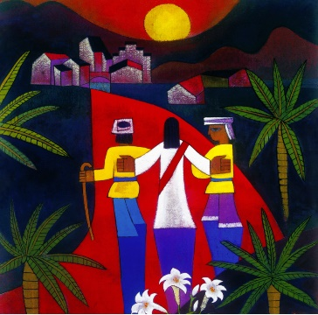
Christians believe:
- That Jesus was resurrected from the dead.
- Hallelujah is a good word to use at Easter, a time of celebration.
- That death is not the end.
- The resurrection makes a difference in how to live well the right way today and how to help others to also live well.
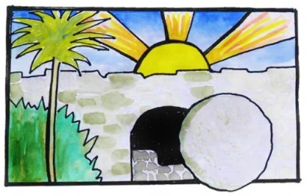



What words should we understand and be able to use?
Resurrection | Resurrection means the raising to life of those who have died. It is a key belief of the Christian faith. | Hallelujah | Hallelujah (Alleluia) is Hebrew for ‘Praise the LORD’ or ‘The Lord’s name be praised. It is used in its original language in Christian worship.
Creed | A list of beliefs, recited by a church congregation as an affirmation of what they believe. | Orthodox | The Orthodox Church is one of the three main Christian groups (the others being Roman Catholic and Protestant).
Palm Sunday | The Sunday before Easter when Jesus entered into Jerusalem on a donkey. | Easter Sunday | The day on which the festival of Easter is celebrated.
Emmaus | Jesus appeared on the road to Emmaus after his crucifixion and resurrection. | Anglican | Relating to the Church of England
A collect | The collect is a short general prayer.

