UKS2 How do the ‘Heroes of Faith’ encourage Christians today?
What should I know?
Knowledge gems | THEOLOGY  Thinking about believing | SOCIOLOGY  Thinking about living | PHILOSOPHY  Thinking about thinking
 | To describe the story of Blondin and know how it illustrates the Christian concept of faith. | Know many Christians go to church regularly to grow their faith (like a mustard seed). To give examples of how they do this. E.g. listening to the Bible, worshipping. | Wonder about what it means to have faith.
 | To know the stories of heroes of faith from the Old Testament such as David, Noah, Moses or Daniel and how Christians interpret these stories. | Know Heroes of Faith encourage Christians experiencing difficult times. Give the example of Nic Vujicic who has shared his faith with others. | Contribute ideas to BQ8 – What are the best ways to think about death and dying?

A Christian’s faith makes a genuine difference to how they live their lives. They grow their faith by using the example of Heroes of Faith found in the Bible.
Christians believe God can be trusted. They say we can put our faith in him and his promises.
Christians believe:
- The Bible contains stories of heroes who showed faith in God and his promises.
- It was by faith that David killed Goliath.
- Growing in ‘faith’ means learning to trust God.
- Christians go to church to worship God and learn together more about their faith so it grows and develops.
- Jesus said faith is like a mustard seed. It starts small but can grow big.

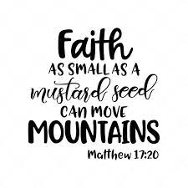
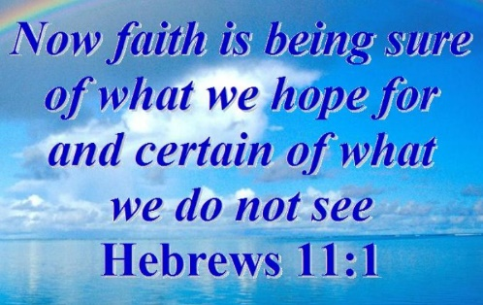


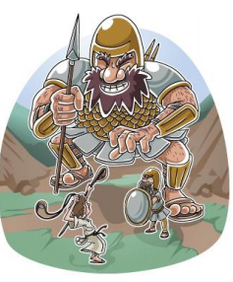

What words should we understand and be able to use?
Faith/ Trust | Faith is a strong belief and complete trust or confidence in someone or something. | Parable | A simple story used to illustrate a moral or spiritual lesson such as those told by Jesus in the Gospels.
New Testament | The second part of the Bible containing the teachings of Jesus, his followers and the experiences of the early church. | Confirmation | Confirmation helps Christians to have a proper understanding of how to live as a follower of Christ. They may go to classes to learn more.
Baptism | The Christian practice of sprinkling water on to a person's forehead or of immersing them in water symbolizing their entry to the Christian Church and the start of their journey following Jesus. | Believers baptism | Baptism administered only to those old enough to make an independent profession of faith.
Baptism |  | Old Testament | The name of the first part of the Bible which was completed before Jesus Christ was born.

