LKS2 How does the story of Rama and Sita inspire Hindus to follow their dharma?
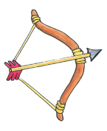
What should I know?
Cycle A  Spring | THEOLOGY | SOCIOLOGY | PHILOSOPHY
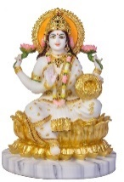   | Hindus believe everyone has their own duty or Dharma to fulfil in life.  For example, Raksha Bandhan is a Hindu festival celebrating brotherhood and love. | Many Hindus in this country celebrate Diwali. Diwali is the festival of lights. | I can ask good questions to do with my duty in life after talking about Rama and Sita, and share my answers
 | The Ramayana is an important Hindu story.  The characters Rama and Sita do their duty. | At a Hindu wedding, the couple is treated as Rama and Sita for the day in an important ceremony called the seven steps. When they marry they take on new duties. | I can contribute ideas to BQ3 - What makes some people an inspiration to others?
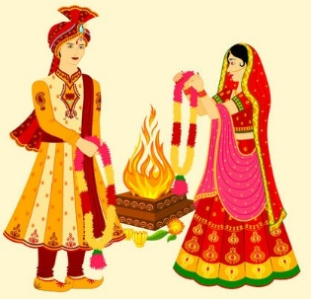
Characters who follow their duty.
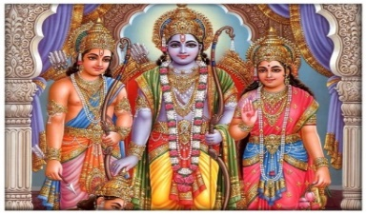
Dharma is about duty.
Hindus believe:
- Everyone has their own DUTY or Dharma to fulfil in life.
- Dharma should be taken seriously -like playing a role in a team.
- Many Hindu stories are about those who follow their duty, no matter what.
- Hindu marriage joins two people for life, so they can fulfil their dharma together.
Home, family and work all have duties.

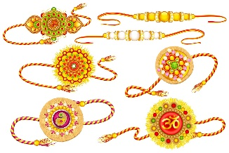
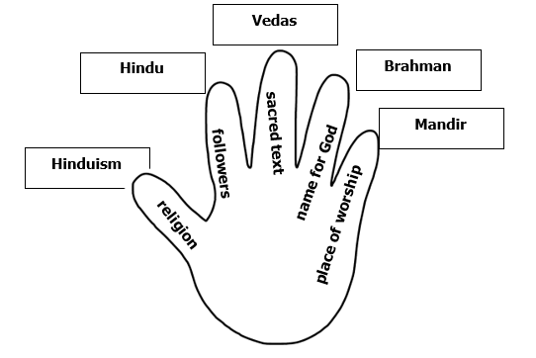
Celebrating sibling duties
What words should we understand and be able to use?
Dharma | This means duty, like playing an important part. Doing your duty. | Diwali | A Hindu festival of new beginnings and the triumph of good over evil, and light over darkness. Known as the 'festival of lights.'
Raksha Bandhan | A Hindu festival celebrating brothers and sisters (siblings) and the love and duty between them. | Ramayana | An ancient Hindu story.
Murti | An image, statue or idol of a deity in Hindu culture. | Divas | 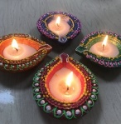  An oil lamp made from clay used during Diwali
Hindu | A follower of the religion Hinduism | Shrine | A holy place to worship
Ceremony | A special event | Seven Steps | The Hindu wedding ceremony
Mandap | A wedding canopy ( a covered structure) | Rama | A Hindu god
Sita | A Hindu goddess | Shiva | One of the main gods in Hinduism

