KS1 What are the best symbols of Jesus’ death and resurrection at Easter?
What should we know?
Cycle A  Spring | THEOLOGY | SOCIOLOGY | PHILOSOPHY
 | The Easter story comes from the Bible.  In the story Jesus dies on a cross but comes back to life.  The story is both happy and sad. | A symbol is a reminder of something important.  The cross is an important symbol to Christians. It expresses different feelings and ideas. | I can ask questions about the Easter story using ‘I wonder…’
 | Some of the objects linked to the Easter story include a cross, silver, palm leaves. There are others too. | Easter is a time of celebration.  During this time Christians may sing special songs, craft, give Easter eggs or light a Easter candle.  These things help them remember Jesus. | I can contribute ideas to the Big Question - Why do people celebrate?
The cross symbolises the whole Christian faith.
Christians believe:
- Jesus died at Easter on a cross but he came back to life.
- Jesus is alive in heaven.
- Easter is a time of celebration.
- The cross is an important symbol.
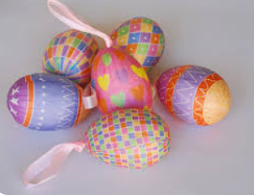
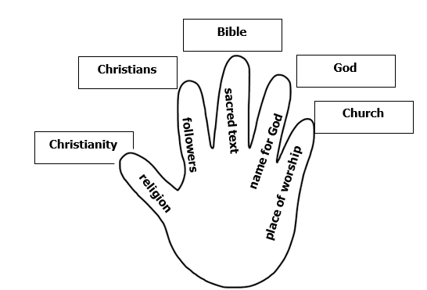


What words should we understand and be able to use?
Resurrection | Jesus comes back from the dead. | Good Friday | The day when Jesus died on the cross.
Easter Sunday | The day when Jesus is resurrected. | Celebration | Celebrating an important day or event.
Easter | The festival remembering the resurrection of Jesus. | Palm Sunday | The Sunday before Easter. Celebrated in many churches.
Symbol | A reminder of something important. | Festival | A time of celebration.
Church | A building for Christian worship. | Christians | Followers of Jesus.
Souvenirs | Something kept as a reminder of a person, place or event. | Crucifixion | When Jesus died on the cross.
Cross | Jesus died on a cross. | Crucifix | A Christian cross with the figure of Jesus on it.

